Coxhoe in the Wars
During World War 1 Great Britain and the Empire mobilised 8.9 million men in the struggle against Germany and their invasion of France, Belgium and eastern Europe. Of those who took the Kings shilling and enlisted for the duration of the war, 908,000 were killed, 2 million were wounded and 191,000 were either taken prisoner or classed as missing.
Coxhoe men, along with every other community in the country did not shirk their sense of duty when it came to stepping forward to fight injustice and aid those less able. At the end of the war, Coxhoe like every other community in the nation paid the ultimate sacrifice. Mothers lost sons, sisters lost brothers, wives lost husbands and children lost fathers. Families were deprived of loved ones and the community lost a generation.
In keeping with every other community nationwide those who lost their lives in the Great War are remembered on the thousands of memorials, rolls of honour, plaques and many other symbols and artefacts that seek to honour those who died.
We could never begin to tell the stories of everyone who served and survived the horrors of war nor could we even scratch the surface of those who died, but we can through the memorials of the village and the resources available today paint a picture of some of the brave men of this village and surrounding district.
Coxhoe War Memorials
Coxhoe and District War Memorial
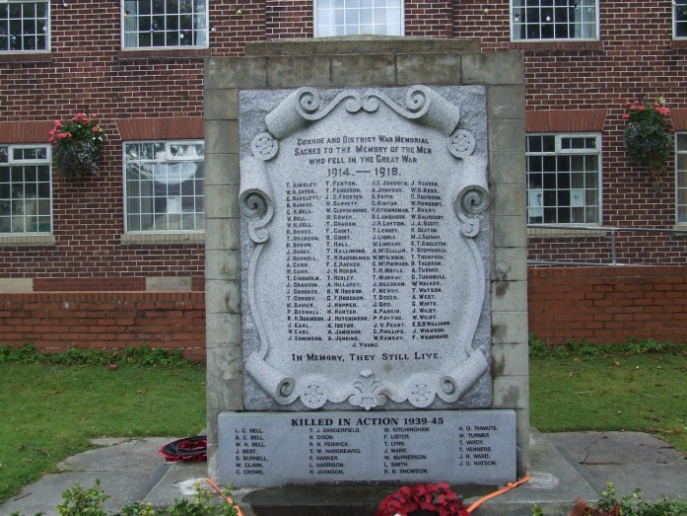

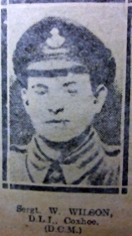
Perhaps the most familiar of all the village war memorials is the one that is most visible. Situated in the centre of the village, in front of the village hall, the memorial is inscribed with the names of 97 men who served and died in the Great War of 1914 -1918 and 28 names of the men who served and died during World War 2, from 1939 -1945. Erected in 1922 at a cost of £125 the memorial was unveiled by 19/833 Sergeant William Wilson DCM & Bar who served with the 19th (Service) Battalion of the Durham Light Infantry during World War 1 having distinguished himself on 2 occasions through his bravery and devotion to duty. Of the 25,000 soldiers awarded the Distinguished Conduct Medal during World War 1, only 490 soldiers received the double award, Sergeant Wilson amongst them. Sergeant Wilson DCM and Bar was a native of Coxhoe.
19/833 Sergeant William Wilson, DCM & Bar. Durham Light Infantry
Made from granite the memorial shield is set in a wall of coarse stone which measures almost 7 feet in height and just over 5 feet wide. Originally set within the wall of the Village Hall, the memorial was later moved to its current location within the small memorial park.
It is worthy of note that the villages of Cornforth, Kelloe, Tursdale and Bowburn also list names of men who appear on the Coxhoe and District War Memorial.
St Marys Church
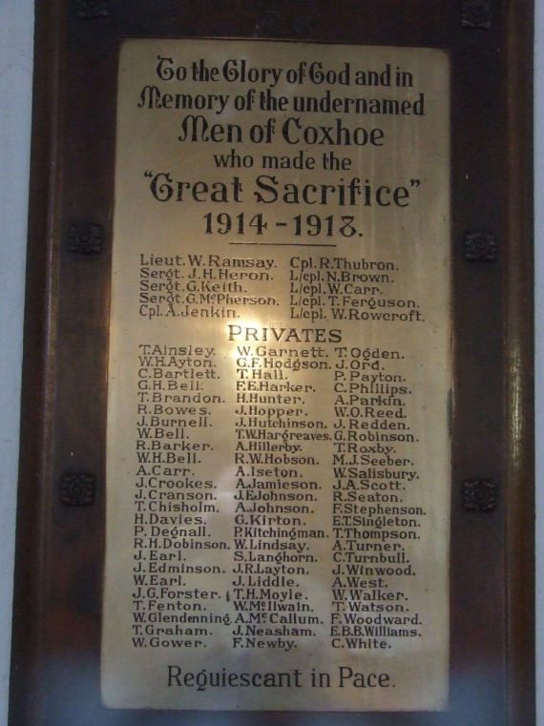
The War memorial within St Marys Church is situated beneath the west window and lists 86 men who died during World War 1. Made of brass and mounted on an oak board the memorial was dedicated in 1920 by Bishop Moule, Bishop of Durham. Officers and Non commissioned officers are at the top of the board with private soldiers beneath.
The altar window inside St Mary’s depicts the ultimate sacrifice with a soldier at the feet of Christ on the cross. The other windows depict the Crosses of St George and St Cuthbert. The window was paid for through public subscription and dedicated by Bishop Moule in 1920 at the time of the dedication of the War Memorial.
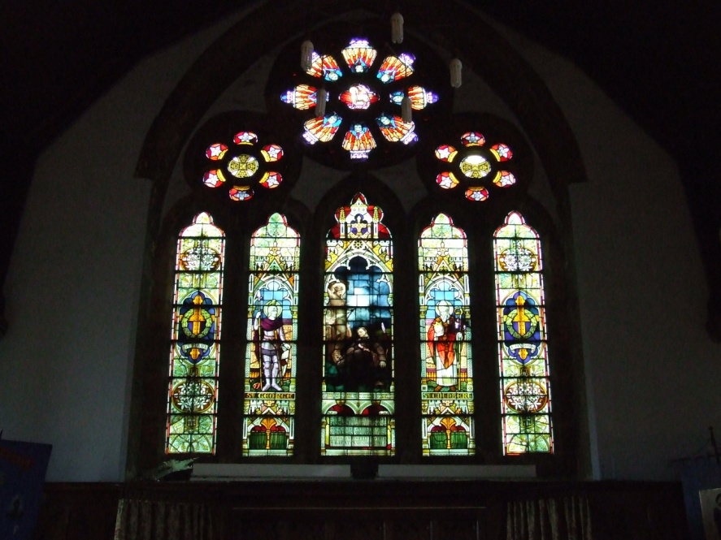
The Altar Window

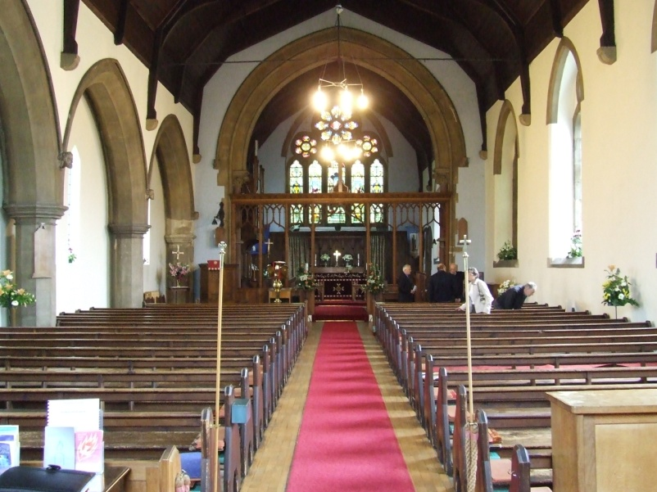
Other acts of remembrance within St Mary’s Church include:-
A Prie Dieu, or prayer desk which is usually used for private prayer is dedicated to the memory of Private 6727 William Ogle Reed of 5th Seaforth Highlanders. William Ogle Reed who resided in Blackgate, Coxhoe was killed in action on 13 November 1916, during the final days of the Battle of The Somme and is interred in Mailly Wood Cemetery, Mailly-Maillet , France.
Follow this link to find details of Private Reed.
http://www.cwgc.org/search/casualty_details.aspx?casualty=111680
William McIlwain resided in Co-operative Terrace Coxhoe and was employed as a Blacksmith. At the outbreak of WW1 he enlisted and joined the 1st Battalion of the Grenadier Guards and embarked for France on the 16th March 1915. William was killed in action on the 4th of June 1915 and is remembered on the Le Touret Memorial in northern France. St Marys Church holds a ewer (jug) in remembrance of William Mcilwain.
Follow this link to find details of Private McIlwain
http://www.cwgc.org/search/casualty_details.aspx?casualty=853702
A vase in the church serves as a reminder to the most senior serviceman to die during the conflict. Lieutenant William James Ramsay of the Royal Flying Corps, resided in West Hetton Lodge, Coxhoe. Lt WJ Ramsay was killed in a crash on 27 March 1918. He was in RE8 B5114 of 52 Sqn when it got into a side slip after take off and crashed in flames. He was the observer and the pilot was 2 Lt RD Turnell, who was also killed. They were heading out on a bombing operation, in all likelihood on the Somme bridges, as the unit had been doing this and contact work in the days preceding. The unit had moved four times in the previous week and crews that day were taking off from yet another new airfield, at Abbeville, in circumstances of the direst emergency.
Lt Ramsay lies at rest in St Pierre Cemetery, Amiens, France
Follow this link to find details of Lieutenant Ramsay.
http://www.cwgc.org/search/casualty_details.aspx?casualty=205091

William David Carr of Cornforth Lane was the second son of William Carr a local butcher. He joined the 13th Battalion of the Gloucestershire Regiment and died in September 1918 during the last weeks of the war as the Allied Forces pushed the German Army back towards the River Rhine. William Carr is remembered in St Marys Church with a wardens staff mounted with the Cross of St Cuthbert.
Follow this link to find details of Private Carr.
http://www.cwgc.org/search/casualty_details.aspx?casualty=286677
Coxhoe Primary School
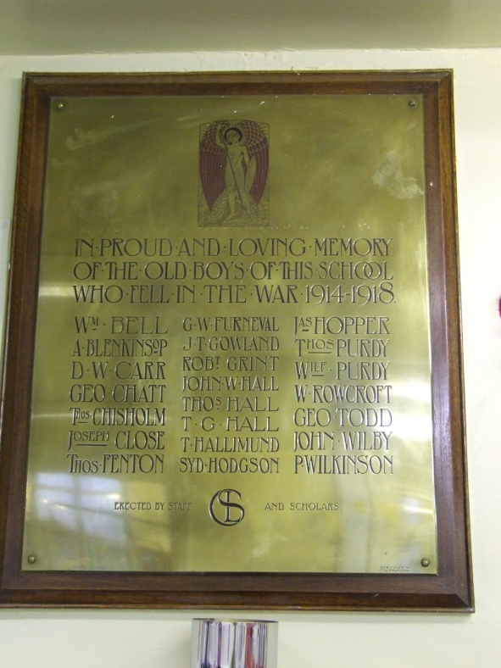
Cornforth Lane School (now Coxhoe Primary School) opened it’s doors to pupils in May 1909 only 5 years before the start of the Great War. Accepting pupils from neighbouring villages as well as Coxhoe, by the end of the war a number of former pupils had fallen.
The plaque was paid for by private subscription from former pupils and staff the school and is made of brass and Oak. The names of 22 former pupils are inscribed on the plaque.
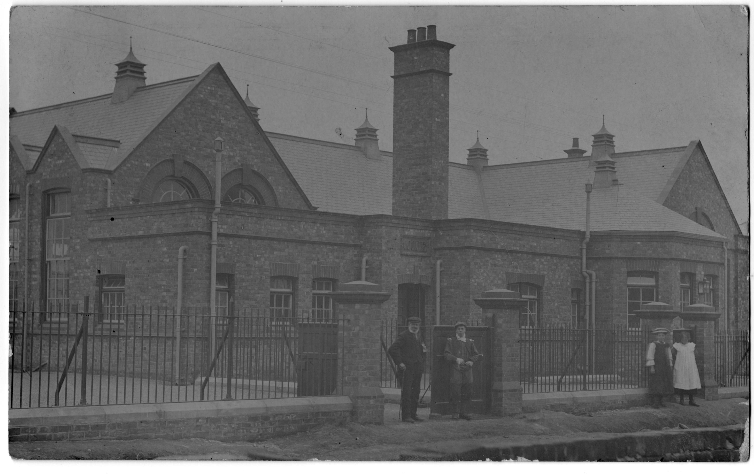
Cornforth Lane School 1909
The Ultimate Sacrifice
Name | Unit | Date Died | Home Address
Ainsley. Thomas | 3 East Yorkshire | 4.5.1915 | Long Row, Coxhoe
Ayton. William H. | 22 Durham Light Inf. | 27.5.1918 | Coronation Terrace, Coxhoe
Bartlett. Charles | 1/5 Durham Light Inf. | 25.5.1915 | Long Row, Coxhoe
Barker. Robert.H | 2 Durham Light Inf. | 21.9.1914 | Front Street, Coxhoe
Bell. George H. | 22 Durham Light Inf. | 27.5.1918 | West Terrace, Coxhoe
Bell. W | Details unknown |  | Contact webmaster with info.
Bell. William H. | 3 Worcestershire Regt. | 25.9.1918 | Church Street, Coxhoe
Bowes. Ralph | 1/3 Dur. Fort Coy. R.E | 14.7.1916
Brandon. Thomas | 22 Durham Light Inf. | 4.3.1917 | Coronation Terrace, Coxhoe
Brown. Norman | 1/5 Durham Light Inf | 7.9.1916
Burke. John | 1/5 Durham Light Inf | 21.4.1917 | Front Street, Coxhoe
Burnell. James | 8 N/land Fus. | 15.9.1915 | Front Street, Coxhoe
Carr. Anthony | 13 Durham Light Inf. | 4.8.1916 | Long Row, Coxhoe
Carr. William | 13 Gloucestershire Reg | 27.9.1918
Chisholm. Thomas P | 7 N/land Fus. | 25.10.1917 | Dundee House, Cornforth Lane.
Cranson. James | 8 Yorkshire Regt. | 3.10.1916
Crookes. Jos. Ed. | 6 East Kent Reg. | 27.8.1918 | Front Street, Coxhoe
Crosby. Thomas | 15 Durham Light Inf. | 17.7.1916 | Cornforth Lane, Coxhoe
Davies. Horace | 8 N/land Fus. | 19.8.1915 | Bowburn Cottage, Coxhoe
Duignan. Philip | 24 N/land Fus. T.Irish | 1.7.1916 | Born Coxhoe Pottery
Dobinson. Robert H | 9 Yorkshire Regt. | 14.8.1917 | Long Row, Coxhoe
Earls. John J | 1/5 Durham Light Inf. | 24.5.1915 | Copes Buildings, Coxhoe
Earls. William | 4 Yorkshire Regt. | 24.5.1915 | Copes Buildings, Coxhoe
Edmonson. John R. | 1 N/land Fus. | 23.10.1918 | Foundry Row, Coxhoe
Fenton. Thomas | 2 K.O.S.B. | 13.10.1914 | Church Street, Coxhoe
Ferguson. Thomas | 3/5 Lancashire Fus. | 9.10.1917 | Co-operative Terr. Coxhoe
Forster. John G | 5 Yorkshire Regiment | 28.9.1916 | Front Row, Coxhoe
Garnett. Wilfred J | 8 East Yorkshire Reg. | 14.7.1916 | Front Street, Coxhoe
Glendinning. William | 22 Durham Light Inf. | 4.3.1917 | Co-operative Terr. Coxhoe
Gower. William | Royal Navy | 31.5.1916 | Basic House, Coxhoe
Graham. Thomas | 2 South Staffs Regt. | 28.9.1918 | Front Street, Coxhoe
Grint. Fred | 22 Durham Light Inf. | 26.3.1918 | Cornforth Lane, Coxhoe
Grint. Robert | 15 Durham Light Inf. | 23.10.1918 | Cornforth Lane, Coxhoe
Hall. Thomas G | 8 Durham Light Inf | 26.8.1918 | Clarence Villa, Coxhoe
Hallimand. John T | 1/5 Durham Light Inf | 24.5.1915
Hargreaves. Thomas W | 25 N/land Fus. T. Irish | 1.7.1916 | Front Street, Coxhoe
Harker. F E | Details Unkown |  | Contact webmaster
Heron. John H | 1/5 Durham Light Inf. | 15.2.1916
Hedley. Thomas | 10 Yorkshire regt. | 12.7.1916 | Gladstone Terr. Coxhoe
Hillarby. Alfred | 11 Royal Fusiliers | 30.8.1918 | Basic Cottages, Coxhoe
Hobson. Robert W | 18 K.R.R. Corps | 28.3.1918 | Vicarage Terr. Coxhoe
Hodgson. George J. | 16 Durham Light Inf. | 10.5.1917 | Church Street, Coxhoe
Hopper. James | 1/5 Durham Light Inf. | 8.4.1919 | Victoria Terrace. Coxhoe
Hunter. Henry | 22 Durham Light Inf. | 16.6.1916 | Heugh Hall
Hutchinson. John | 14 Durham Light Inf. | 19.12.1915 | Stable Row, Cassop
Iseton. Albert E | 22 Durham Light Inf. | 27.5.1918 | Blackgate, Coxhoe
Jamieson. Alexander | 1 Cameron Highlanders | 22.7.1916
Jenkin. John | 13 Liverpool Regiment | 16.5.1917 | Born Coxhoe Bridge
Johnson. Allan | 13 Durham Light Inf. | 19.9.1916 | Prospect House, Coxhoe
Johnson. Joseph E | 2 Royal Fusiliers | 3.7.1916 | Coke Oven, Coxhoe
Keith. George MM | Royal Field Artillery | 13.9.1917 | Church Street, Coxhoe
Kirton. George | 1/5 K.O.R Lancasters | 26.9.1917
Kitchingman. Parker | 1/5 Durham Light Inf. | 9.11.1915 | Joint Stock Cottage, Coxhoe
Langhorn. Sidney | 1/5 Durham Light Inf. | 7.8.1916
Name | Unit | Date Died | Home Address
Layton. John R | 2 Machine Gun Corps | 31.10.1918
Lenney. Thomas M | 2 Durham Light Inf. | 21.3.1918 | Cornforth Lane, Coxhoe
Liddle. John | 1/5 Durham Light Inf. | 24.5.1915 | Prospect Place, Coxhoe
Lindsay. Robert W. | 1 Loyal Nth. Lancs | 26.9.1916 | Wylam Terrace, Coxhoe
McCallum. Alexander | 2 Border Reg. | 22.2 1916 | Cow Close, Coxhoe
McIlwain. William | 1 Grenadier Guards | 4.6.1915 | Coxhoe
McPherson. George | 15 Durham Light Inf. | 16.9.1916 | Coxhoe
Moyle. Thomas H | 14 Durham Light Inf. | 12.10.1916 | Coxhoe
Murray. Thomas | 11Durham Light Inf | 10.11.1915 | West Cornforth
Neasham. James | 88 Training Reserve | 19.2.1917 | Thrislington Hall Farm.
Newby. Frank | 2 Durham Light Inf | 26.6.1916 | Cassop Colliery
Ogden. Thomas | 6 Yorkshire Reg. | 15.9.1916
Ord. John Intin | 447 Coy R.E. | 27.5.1918 | Blackgate, Coxhoe
Parkin. Aaron | 13 Gloucestershire Reg | 30.6.1916 | Longstaffs Buildings, Coxhoe
Payton. Patrick | 24 N/land Fus. T. Irish | 1.7.1916
Peart. Joseph V MM | 1/3 Durham Light Inf. | 10.4.1918 | Gladstone Terrace, Coxhoe
Phillips. Charles | 29 Machine Gun Corps | 2.5.1918
Ramsay. William J | 52 Sqd R.F.C | 27.3.1918 | West Hetton Lodge, Coxhoe
Redden. John | 6m K.O.Y.L.I. | 16.9.1916 | Long Row, Coxhoe
Reed. William | 5 Seaforth Highlanders | 13.11.1916 | Blackgate, Coxhoe
Robinson. George | 1 West Yorkshire Reg. | 16.7.1918 | Cow Close, Coxhoe
Rowcroft. William | 8 East Yorkshire Reg | 26.9.1915 | Co-operative Terrace, Coxhoe
Roxby. Thomas H | 6 Wiltshire Reg. | 3.11.1918 | Front Street, Coxhoe
Salisbury. Walter | 5/6 Royal Scots | 26.8.1917 | Oddfellows Arms, Coxhoe
Scott. John A | 17 N/land Fusiliers | 2.11.1917
Seaton. Robert | Royal Garrison Artillery | 23.12.1916 | Quarrington Hill
Seeber. Martin J | 22 Durham Light Inf. | 27.10.1916 | West Parade, Coxhoe
Singleton. Edward | 10 Durham Light Inf | 31.7.1915 | Co-operative Terrace, Coxhoe
Stephenson. Fred | 1/5 Durham Light Inf. | 29.9.1915 | Durham Road, Bowburn
Thompson. Thomas | 6th Yorkshire Reg. | 27.9.1916 | Long Row, Coxhoe
Thubron. Robert | 8 East Yorkshire Reg | 13.11.1916 | Oxclose, Coxhoe
Turner. Arthur | 1/5 Durham Light Inf. | 5.11.1915 | Coxhoe
Turnbull. Charles T | Machine Gun Corps | 21.8.1918 | East House Farm, Coxhoe
Walker. William | 20 K.R.R.Corps | 14.7.1916 | Reading Room St. Q.Hill
Watson. Thomas | 1/5 Durham Light Inf. | 25.4.1915 | East Hetton Colliery,Kelloe
West. Anthony | 1/9 Durham Light Inf. | 1.10.1918 | St Helens, Kelloe
White. Charles G | Royal Field Artillery | 3.6.1918 | Coxhoe
Wilby. John B | 11 Royal Fusiliers | 21.9.1918 | Cornforth Lane, Coxhoe
Wilby. William | 14 Durham Light Inf | 27.9.1914 | Cornforth Lane, Coxhoe
Williams. Edward B B | 1/8 Durham Light Inf | 1.10.1918
Winwood. Joseph | Royal Field Artillery | 23.9.1918 | Heugh Hall Row, Old Quarrington
Woodward. Frederick | 20 Durham Light Inf. | 16.9.1916
Young. James MM | 8 East Yorkshire Reg | 14.7.1916

All hyperlinks will take you to the Commonwealth War Graves Commission Web pages and the details of each soldier.
All hyperlinks have been corroborated against Soldiers Died in the Great War to verify the correct soldier.

William Wilson Citation
http://www.london-gazette.co.uk/issues/30983/supplements/12807

